May 21, 2024

The Canadian Nuclear Association (CNA) appreciates the opportunity to comment on discussion paper DIS-24-01, Proposals to Amend the Packaging and Transport of Nuclear Substances Regulations, 2015 and the Nuclear Substances and Radiation Devices Regulations. The CNA has approximately 100 members, representing over 76,000 Canadians employed directly or indirectly in exploring and mining, uranium, generating electricity, advancing nuclear medicine, and promoting Canada’s worldwide leadership in science and technology innovation.
Our comments were prepared after discussion with our members who have extensive experience in the packaging and transport of nuclear substances. Detailed comments are contained in tables submitted directly by our members; however, CNA would like to highlight several key concerns.
Our members are concerned that the proposed amendments require Canadian companies to meet special requirements that do not apply to other countries thereby putting Canadian companies at a competitive disadvantage.
- A good example is the 3% mass restriction for Low Specific Activity (LSA-I) material which requires special packaging. While Canadian ores have a significantly higher uranium concentration than most countries, the 3% restriction is not justified on either a radiation basis or activity limit. The result of Canada not harmonizing with the rest of the world is that Canadian companies must use special packages not used by other companies, thus reducing our international competitiveness. These regulatory changes should take the opportunity to harmonize the PTNSR definition of LSA with the IAEA regulations.

- Another example is the restriction requiring the use Industrial Package Type IP-3 for the transport of LSA material and Surface Contaminated Material (SCO). This limit does not exist in any other national or international regulation and prevents the effective transport of LSA and SCO material across the border. All other jurisdictions have safely transported Type IP-1 or IP-2 packages, as “non-exclusive use” for years. The CNSC must minimize the number of variations from the IAEA Regulations to allow the effective and efficient movement of goods internationally.
CNA members are also concerned that the proposed amendments overlook opportunities to align Canadian regulations with international regulations. A harmonized transportation regime has been created to allow safe and efficient worldwide movement of radioactive

materials. This approach works best if countries recognize the consensus decisions made by the competent authority of the member states. While the CNSC recognizes the value in this perspective, the CNSC has not achieved its objective of better alignment with the International Atomic Energy Agency’s (IAEA) Regulations for the Safe Transport of Radioactive Material (SSR-6) (the IAEA Regulations). The proposed PTNSR continue to have Canadian specific variations that are not found in the IAEA Regulations and place Canada at a competitive disadvantage.
Another concern expressed by CNA members is the increased administrative burden in this discussion paper. For example, Proposed Amendment 7.6 designed to clarify reporting requirements for improperly classified material. As written, the amendment may deem conservatively classified shipments as reportable when there is no threat to the environment, health and safety of people or national security thus placing unnecessary administrative burden for no safety benefit.
As noted above, you will find other examples and further details in the comment table submitted by our members.
In conclusion, the CNA believes that the amendments described in the discussion paper need to be revised to achieve CNSC’s objectives of better international alignment, better alignment within the NSCA and its regulations, thus reducing administrative burden and placing Canadian companies on an equal footing with their competitors. The CNA believes this alignment can take place without any risk to the environment, public safety or national security and we would urge the CNSC to move in this direction.

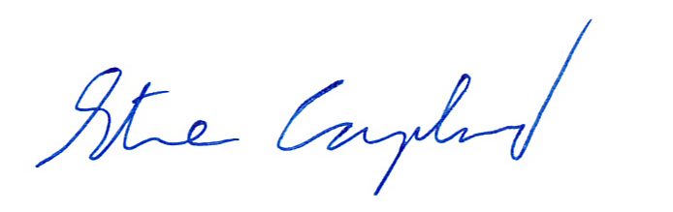
Sincerely,

Steve Coupland
Acting Director, Regulatory Affairs
Canadian Nuclear Association

