June 8, 2024

The Canadian Nuclear Association (CNA) appreciates the opportunity to comment on discussion paper DIS-24-03, Proposal to Amend REGDOC 2.13.1, Safeguards and Nuclear Material Accountancy. The CNA has approximately 100 members, representing over 76,000 Canadians employed directly or indirectly in exploring and mining, uranium, generating electricity, advancing nuclear medicine, and promoting Canada’s worldwide leadership in science and technology innovation.
Our comments were prepared after discussion with our members who have extensive knowledge in the possession of nuclear material, carrying out specific types of nuclear fuel-cycle related R & D or carrying out specific types nuclear-related manufacturing activities. Detailed comments are contained in tables submitted directly by our members; however, CNA would like to highlight several key concerns:
- As also noted in our comments on DIS-24-02, CNA recommends that a CNSC/Industry workshop be held prior to the drafting of the REGDOCs.

- CNA and its members are concerned that as additional information describing the Safeguard Agreement and Additional Protocol requirements are incorporated within the REGDOCs that additional requirements could be inadvertently introduced. NSCA regulations and the REGDOCs need to remain aligned with the Safeguard Agreement and Additional Protocol.

- While the CNSC has provided a clarification to uranium mines and mills that uranium ore within a mining or milling process circuit is exempt from safeguard reports, CNA would like to see this exemption explicitly stated in the regulations.

- The absence of a strong and robust descriptions of what Safeguards are (or aren’t) has led to ambiguity and misinterpretation of the program particularly by other programs. CNA recommends the addition of a strong, robust description of a Safeguards program and its interaction with other CNSC programs particularly Cyber Security and Physical Security. This would be an important topic to cover in a workshop.

- Our members would like greater clarification around any potential role with the operation of IAEA safeguard equipment. There is potential to expose facility personnel to potential REGDOC 3.1.1 reportable events as well as potentially require the deployment of significantly more resources to support IAEA operations. Also, IAEA inspections are conducted in accordance with the Additional Protocol and CNSC REGDOCs need to remain aligned with that protocol. This is another issue that would benefit from in-depth discussion at a workshop.

- Section 2.12 refers to “tags”. It is unclear what a tag refers to and if it is different from an item’s unique identifier. As well much of industry’s nuclear material is ONLY tracked digitally or through paper and using in-field identifiers. Tags would not be practical for many of these items.

In conclusion, the CNA strongly urges the CNSC to hold a CNSC/Industry workshop to discuss the items listed in our submissions on DIS-24-02 and DIS-24-03

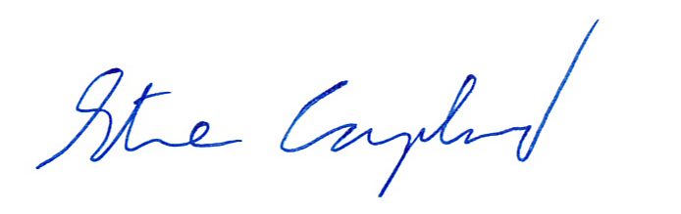
Sincerely,

Steve Coupland
Acting Director, Regulatory Affairs
Canadian Nuclear Association

